Tool Safety

Pedestal Grinder
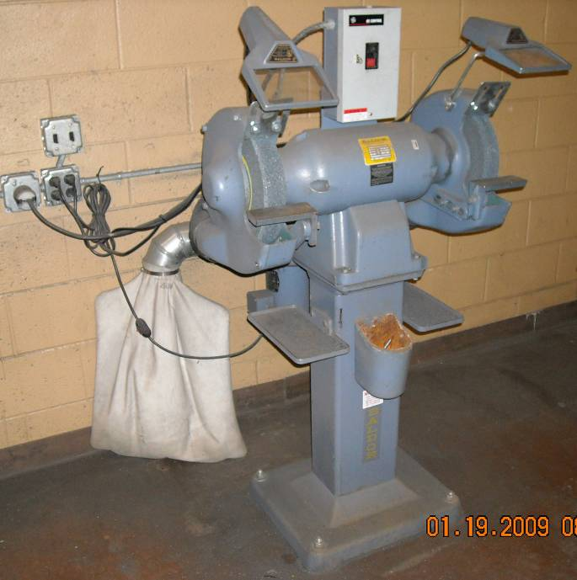
- Always wear safety glasses and a clear face shield
- Always use the tool rest, don’t freehand grind.
- The tool rest must be fastened securely with about a 1/16 inch of clearance between it and the wheel. A maximum clearance is 1/8 of an inch.
- Never install a grinding wheel. See your instructor for instruction.
- Ensure that no one is inside the operator's zone while you are operating the grinder. One person uses the grinder at a time.
- Ear plugs (hearing protection) are recommended.
- Always check a grinding wheel for cracks, defects, or impregnated aluminum prior to use. Don’t grind soft materials such as aluminum, brass, and wood.
- Use the correct type of grinding wheel. There are different wheels designed to grind aluminum.
- Ensure the tongue guard is in place and securely fastened.
- Ensure the grinder has a true, balanced, and dressed wheel. Notify the instructor if the wheel needs to be dressed.
- Stand to one side of the grinder when turning it on.
- Move back and forth across the cutting surface (FACE of the grinding wheel), to keep the wheel from being grooved.
- Never grind on the side of a wheel in the welding lab.
- Keep the work cool by quenching it in the water pot.
- Press work material against the wheel using a fair amount of pressure. Do not overload the machine.
- Remember to turn the grinder off immediately after you are done (walk away). Wash your hands to remove abrasives or metal dust. Don’t touch your face or eyes.

