Flux-Cored Welding: The Basics for Mild Steel
By Joel Ort, welding technician, Miller Electric Mfg. Co.
The following article and associated video provides an overview for beginners to learn self-shielded flux-cored welding techniques with a wire feed welder designed for both beginners and professionals, the Millermatic® 212 Auto-Set™. The article focuses on welding mild steel and covers the following topics:
• Safety
• Material preparation
• Equipment preparation
• Electrode (wire type) selection
• Setting parameters
• Wire stick-out
• General gun mechanics
• Welding in different positions
Self-shielded flux-cored welding can be an excellent process to use for welders of all skill levels who frequently need to weld outside or on dirty material.
Self-shielded flux-cored welding is a wire welding process in which a continuous hollow wire electrode is fed through the welding gun into the weld joint. Self-shielded flux-cored welding differs from MIG welding in that it doesn’t require an external shielding gas, such as CO₂ or Argon, in order to protect the weld pool from contamination*. Instead of an external shielding gas, a flux compound contained within the hollow wire reacts with the welding arc to form a gas that protects the weld pool — it can be thought of as an inside-out Stick electrode.
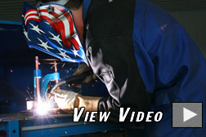
Because the flux creates the shielding gas, it does not encounter the weld problems that can occur when MIG welding outside and a strong wind blows the shielding gas away. The flux contained in the electrode also allows the process to be more forgiving of base metal that is somewhat rusty, dirty or otherwise contaminated.
Flux-cored welding does produce a slag that sits on top of the finished weld and must be chipped off, similar to Stick welding, and it also tends to produce welds that aren’t as visually attractive as MIG welds. For these reasons, if you own a power source capable of performing MIG and flux-cored welding, it makes sense to switch to the MIG process for welds that will be made indoors.
First Things First
Before tackling any repair or fabrication project, be sure you have the proper safety gear: leather boots (steel toes are ideal), full length cuff-less pants, a flame-resistant jacket, leather gloves with forearm protection, a proper welding helmet and a bandana or “skull cap” to protect the top of your head. Also, be sure to remove any fire hazards from the welding area.Miller’s Arc Armor™ line ofsafety apparel offers a wide range of these accessories for everyone from the occasional hobbyist to the full-time professional welder. Also, be sure to check your owner’s manual for additional information about safety apparel and precautions.
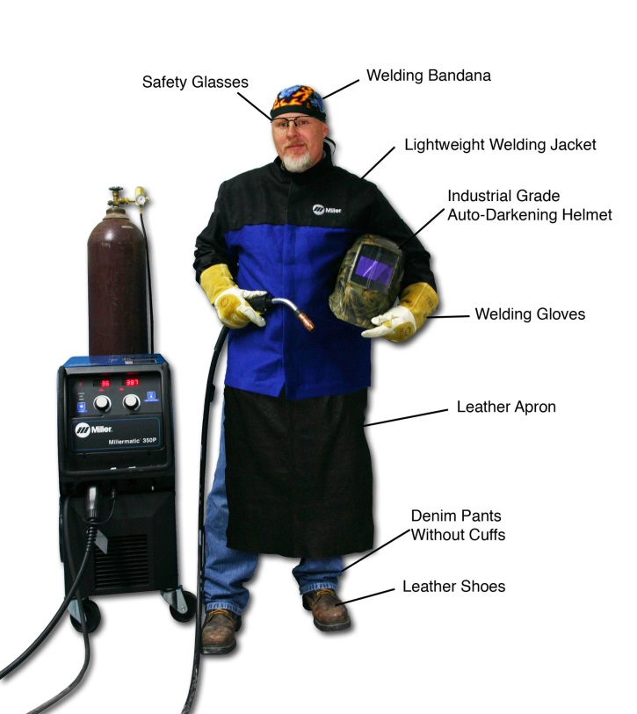
Proper safety equipment should always be the first priorty when welding
Metal Preparation
As mentioned earlier, flux-cored welding is more tolerant of surface contamination than MIG welding. However, it’s always a good idea to clean the surface of the base metals as thoroughly as possible to ensure that a rusty or scaly surface does not contaminate the final weld. A metal brush or grinder work well for cleaning the base metals. Also, be sure to clean the portion of the base metal to which the ground clamp will be attached. Poor contact with the ground clamp will create resistance in the welding circuit and could result in poor weld quality.
For material over 1/4-in., it’s usually a good idea to bevel the edges of the base materials to ensure complete fusion of the two parts — this is especially true for butt joints.
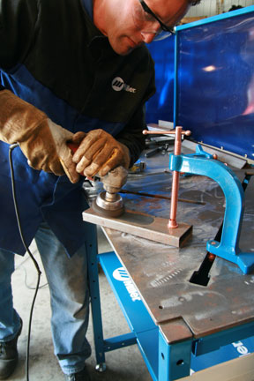
Although flux-cored welding is more forgiving of dirty
metal than MIG welding, it’s still a good idea to clean
off as much surface contamination as possible prior to welding.
Equipment Preparation
- Check your cables: Before striking an arc, check your welding equipment to make sure all of the cable connections are tight fitting and free of fraying or other damage.
- Select electrode polarity: Flux-cored welding requires DC electrode negative, or straight polarity. The polarity connections are usually found on the inside of the machine near the drive rolls.
- Use the correct drive rolls: Because flux-cored wire is softer than solid wire, knurled drive rolls provide a good “bite” on the wire without compressing and deforming it — which could happen if standard drive rolls are used.
- Check wire tension. Too much or too little tension on either the drive rolls or the wire spool hub can lead to poor wire feeding performance. Adjust according to your owner’s manual.
- Inspect consumables. Remove excess spatter from contact tips, replace worn contact tips and liners and discard the wire if it appears rusty.
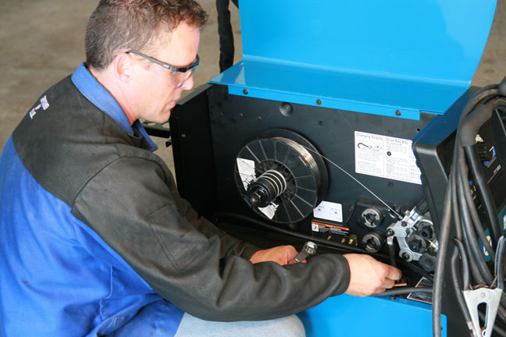
Be sure to conduct a thorough inspection of your equipment prior to welding.
Wire Selection
For general purpose mild steel applications, a flux-cored wire with the designation E71T-11 or E71T-GS can be used in any position, is available in a wide range of sizes and provides excellent welding characteristics for both thin and thicker material. Hobart Brothers offers both of these wires under the names Fabshield 21B (E71T-11) and Fabshield 23 (E71T-GS).
As for wire diameter, .030-in. diameter makes a good all-around choice for welding a wide range of metal thicknesses. For welding thicker material at higher total heat levels, use .035-in. (or .045-in. wire if it’s within your welder’s output range).
Voltage and Amperage
How much voltage and amperage a weld requires depends on metal thicknesses, joint configuration, welding position, and wire diameter. Reference charts are available on your power source and athttp://www.millerwelds.com/ to help set the correct voltage and wire feed speed based on the wire diameter and material thickness. These charts should be considered rough guides from which you can fine tune your final parameters based on a couple test welds.
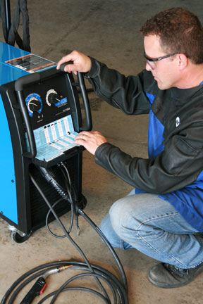
Your power source contains reference charts for setting
the correct electrical and wire feed parameters.
Wire Stick-out
Stick-out is the length of unmelted electrode extending from the tip of the contact tube, and it does not include arc length. Generally, flux-cored welding requires a stick out of around 3/4-in., which is about twice the recommended stick out for MIG welding.
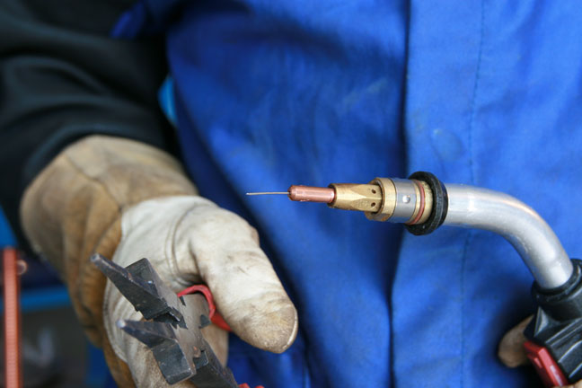
A stick-out of approximately 3/4-in. is recommended for flux-cored welding.
Push or Drag?
With flux-cored welding, you should always use a drag (pull) technique, in which the tip of the welding gun is being pointed back at the weld pool and “dragged” away from the completed weld. An easy rule-of-thumb for remembering whether to use a push or drag (backhand) technique is: “If there’s slag, you drag.”
Travel Angle
Travel angle is defined as the angle relative to the gun in a perpendicular position within the plane of the weld joint. Normal welding conditions in all positions call for a travel angle of 5 to 15 degrees. Travel angles beyond 20 to 25 degrees can lead to more spatter, less penetration and general arc instability.
Work Angle
Work angle is the gun position relative to the plane of the welding joint, and it varies with each welding position and joint configuration (see below).
Flat Position
- Butt weld (a “180-degree” joint): Hold the gun at a 90-degree work angle (the same angle from each workpiece), directing the filler metal straight into the joint with a 5 to 15-degree travel angle. A small, side-to-side motion with the gun can help fill a large gap or when making multiple passes. A slight pausing at the side of a weave bead can help avoid undercut.
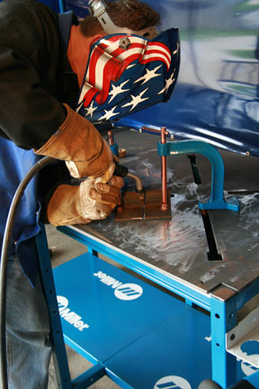
- T-joint (a 90-degree joint; the type of weld on this joint is called a “fillet weld”): Keep the gun at a 45-degree angle, or equal distance from each piece. When making multiple weld passes, the work angles change slightly toward one side and then the other. This helps avoid uneven weld beads and undercuts.
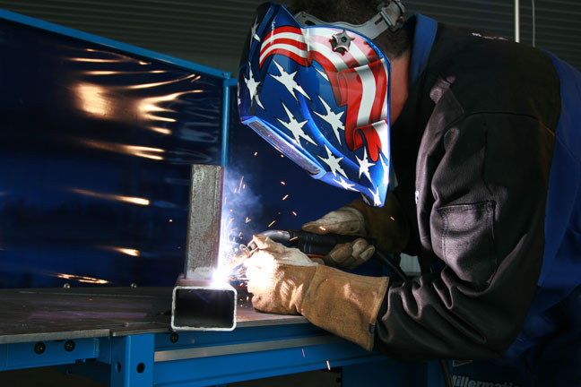
- Lap joint (also a fillet weld): Angle the gun between 60 and 70 degrees to direct more heat into the bottom piece of metal. The thicker the metal being welded, the greater the angle.
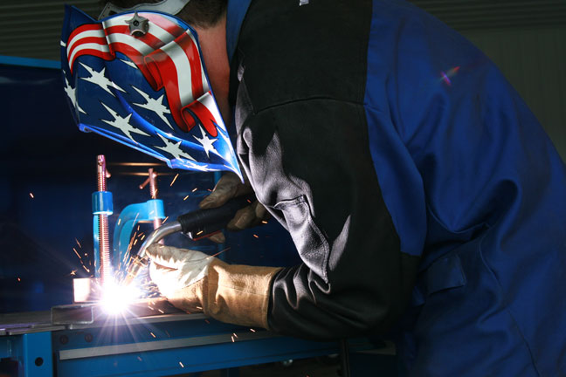
Horizontal Position
Because of the effects of gravity, the gun work angle must be dropped slightly by 0 to 15 degrees so that the welding gun is pointing upward toward the top piece of metal. Without changing the work angle, the filler metal may sag or rollover on the bottom side of the weld joint. The travel angle generally remains the same as for a weld joint in the flat position.
On thick metal when making multi-pass welds, or to bridge a slight gap where fit-up is poor, a slight weave may be used to fill a weld joint. A slight hesitation at the top toe of the weld helps prevent undercut and ensure proper tie-in of the weld to the base metal. Voltage and amperage settings for welding in the horizontal position are usually the same or very slightly less than settings for welding in the flat position.
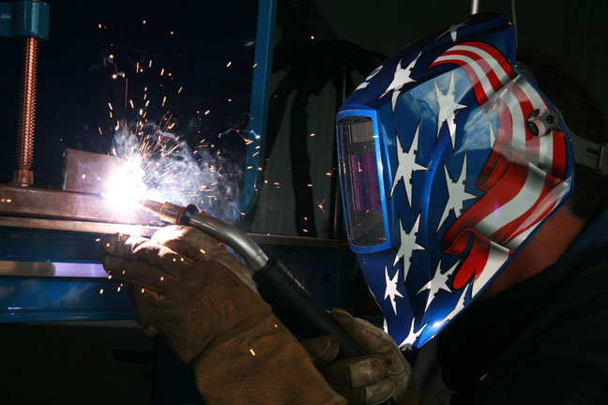
Angle the welding gun slightly upward for horizontal welds in order to accommodate for gravity.
Vertical Positions
Vertical welding, both up and down, can be difficult. This makes pre-weld set-up very important for making high quality welds. Since you are fighting gravity, consider reducing the voltage and amperage 10 to 15 percent from the settings for the same weld in the flat position.
- The vertical down technique helps when welding thin metals because the arc penetrates less due to the faster travel speed. When welding vertical down, begin at the top of a joint and weld down, weaving slightly side-to-side. For thin metal where burn-through is a concern, keep the electrode wire on the leading edge of the weld puddle.
- The vertical up technique is basically the same as vertical down, but can provide better penetration on thicker materials (typically 1/4 in. or more). The travel angle of the gun is a 5 to 15 degree drop from the perpendicular position with a slight weaving motion.
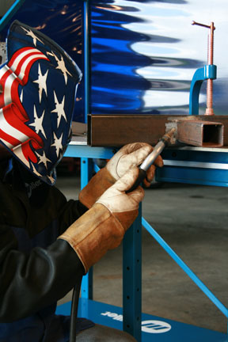
Remember to weld upward for increased penetration and downward for thinner metals.
Overhead Position
An overhead weld is the most difficult weld to make, and in general it should be avoided if possible. If you cannot avoid welding in the overhead position, try using the smallest wire possible, lowering your welding parameters by 15 to 20 percent, keeping your weaving to a minimum and maintaining a fast travel speed. Even following these tips, it still may be difficult to achieve a sound overhead weld.
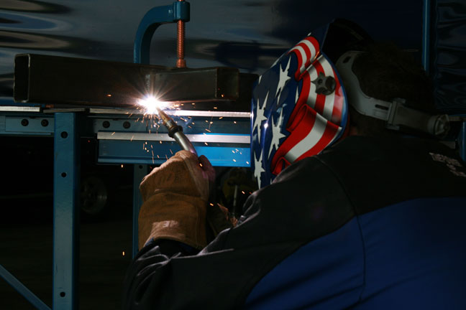
Overhead welds are tricky. Use a thin wire, fast travel speed and
turn your electrical parameters down by 15-20 percent.

Practice, Practice, Practice!
Creating a successful flux-cored weld (or any arc weld for that matter) requires more than just memorizing the correct parameters and gun travel guidelines. Only through practice and learning to “read” the weld pool will you be able to consistently achieve sound flux-cored welds. Also with practice, you’ll begin to learn to troubleshoot and self-correct any shortcomings in your welds.
So, don’t get frustrated if your welds don’t look perfect on your first try. Just keep practicing and before you know it, you’ll be scouring your garage for new things to repair or fabricate! For more information, including troubleshooting advice, visit the MIG Resources page on Miller’s Web site.
###
* Note: There is also gas-shield flux-cored welding, which does require a shielding gas. This type of wire is primarily employed in very heavy-duty industrial fabrication and manufacturing and is not recommended for most beginner and hobbyist applications.

Duel shield and self-shield (explain):
Types of filler wire:
Typical sizes of wire:
AWS electrode classification:
Use of self-shielded welding:
Use for dual shielded welding:
PPE required:
Metal preparation before welding:

