Drill Press
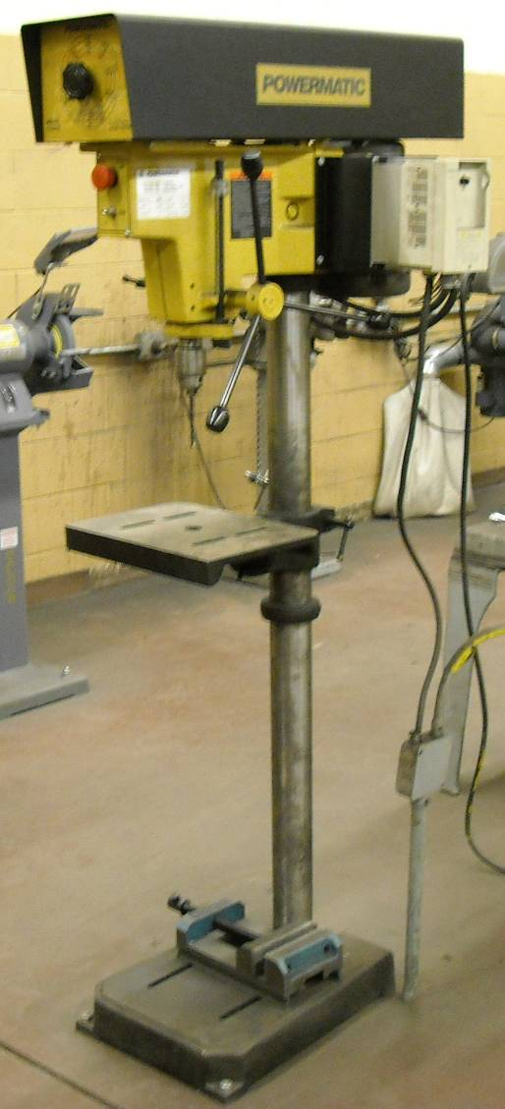
- Wear appropriate safety glasses.
- Ensure that the drill press has a start/stop button within easy reach of the operator.
- Use a hand brush to remove cuttings.
- Remove burrs and chips from a drilled hole. When making deep holes, clean out the hole frequently.
- Use a clamp or drill vise to prevent work from spinning.
- Lubricate drill bit when drilling metal. Run at correct cutting speeds.
- Reduce the drilling pressure when the drill begins to break through the workpiece. This action prevents drill from pulling into the work and breaking.
- Keep drill bits clean and sharp. Dull drills are a common cause of breakage.
- Keep floor around the drill press free of oil and grease.
- Keep the working surface clean of scraps, tools and materials.
- Keep guards in place and in good working order.

